Step1: Open first command prompt. Provide the path of the project. Run the server side by giving the command “rmic”.

**rmic chatServer.Server**

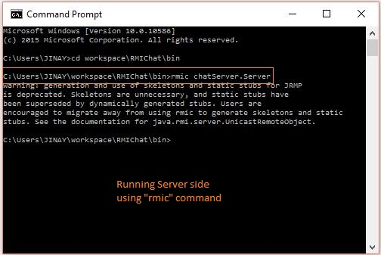

Step 2: In the same command prompt provide the client side information by again giving the rmic command.

**rmic chatClient.Client**

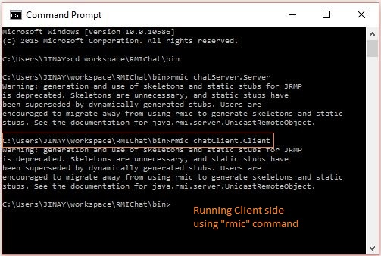

Step 3: In the same command prompt run the registry by giving the command **rmiregistry**.

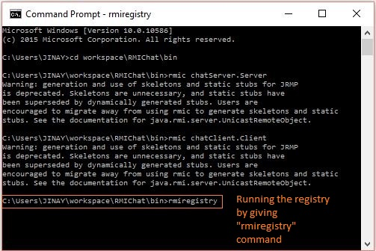

Step 4: Open second command prompt and enter the path again. Give the server side path to run ServerMain.

**java chatServer.ServerMain**

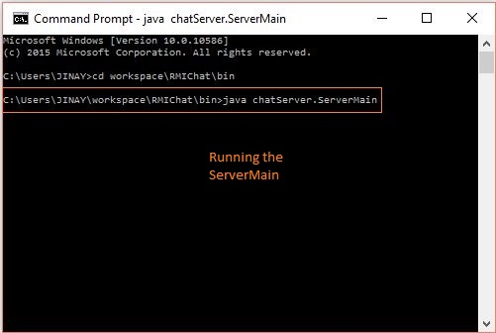

Step 5: Open third command prompt. Provide the path and enter the client’s name, location (X and Y axis) and age.

**java chatClient.ClientMain Jinay 30 55 23**

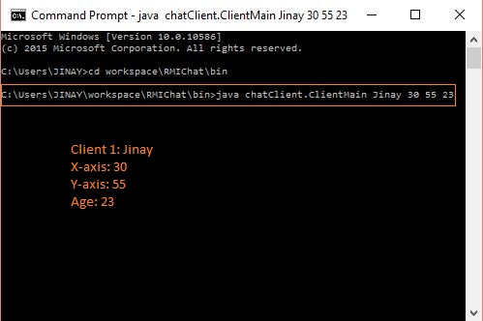

From the screenshot it is clear that Client 1 is Jinay with X-axis as 30 and Y-axis as 55 and Age 23

Step 6: Open the fourth command prompt. Provide path and enter second client’s information like in step 5. Here the Client 2 is Aalesh with X-axis as 78 and Y-axis as 49 and Age 20

**java chatClient.ClientMain Aalesh 78 49 20**

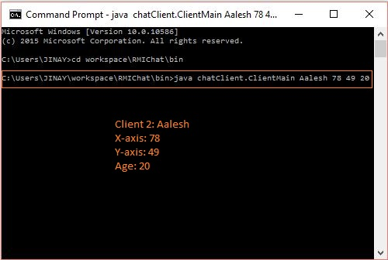

Step 7: Next step is implement “go” and “get location” feature of the program. As an example **“go -50 30“** will shift its current location of client from 50m south and 30m east. So, the new location of the client would be -20 85 as shown in the below screenshot.

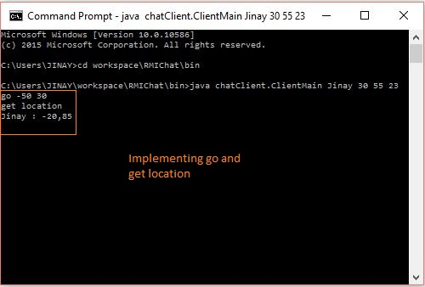

Step 8: “**list 30”** command will get all the clients available within the range of 30 m.

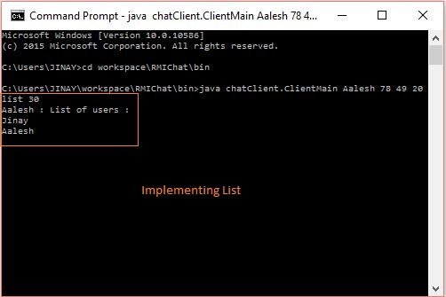

Step 9: Next feature to implement is send feature. Type send along with “client name” and then type the message you want to send to client and the message will be displayed to the other client.

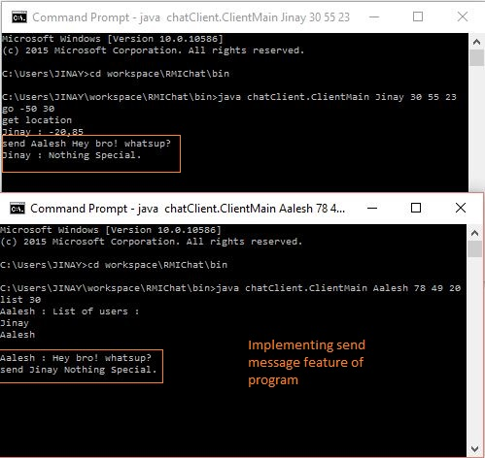

Step10: Now implementing the last feature of the program. Quit functionality. Simply type quit in any of the client window and the client will leave the program. 